Hana Ahmed 202301071
CSAI 422 Assignment 4 Report — Advanced RAG on PopQA

Overview
This project implements an advanced text-only Retrieval-Augmented Generation pipeline for factual question answering on PopQA. The system compares dense retrieval, query-expanded dense retrieval, hybrid retrieval, reranking, citation-grounded generation, and self-reflective answer revision.

Dataset Setup

The PopQA dataset was used as the benchmark for this assignment. It contains factual question-answering examples, where each question is linked to a subject entity, relation, and expected answer. This makes it suitable for testing whether a RAG system can retrieve the correct evidence and generate a grounded factual answer.

After loading the dataset, I inspected its structure and identified the most important fields for the experiment:

- `question`: the natural-language question used as the input query.
- `obj` and `possible_answers`: the gold answer and accepted answer aliases used for evaluation.
- `subj`: the subject entity mentioned in the question.
- `prop`: the relation or property being asked about.
- `s_aliases`: alternative names for the subject entity, used during query expansion.
- `s_wiki_title`: the Wikipedia title connected to the subject entity, used to help construct the retrieval corpus.

To make the experiment reproducible and manageable in Google Collab, I selected a subset of 100 questions using `random_state = 42`. This allowed the same questions to be used across all retrieval methods, making the comparison between dense retrieval, query expansion, hybrid retrieval, and reranking fair and consistent.
Retrieval Corpus
The retrieval corpus was built from Wikipedia summaries corresponding to PopQA subject pages, plus additional distractor pages. Each passage preserved:
- passage id (`pid`)
- title
- source URL
- passage text
Corpus statistics:
- Raw Wikipedia documents: 49
- Total passages: 57
- Embedding dimension: 384
- FAISS index size: 57

Baseline Dense Retrieval
The embedding model used was `sentence-transformers/all-MiniLM-L6-v2`. It was selected because it is lightweight, fast on Colab, and suitable for semantic retrieval.A FAISS inner-product index was created using normalized embeddings, so similarity approximates cosine similarity.

Baseline Results
System | Recall@1 | Precision@1 | Recall@3 | Precision@3 | Recall@5 | Precision@5 | MRR
Dense baseline | 0.27 | 0.27 | 0.30 | 0.116667 | 0.34 | 0.102 | 0.295
The dense baseline achieved Recall@1 of 0.27 and Recall@5 of 0.34. This means that the correct answer appeared in the top retrieved passage for 27% of the evaluation questions and appeared somewhere in the top 5 passages for 34% of the questions. The MRR score of 0.295 shows that when relevant evidence was retrieved, it was not always ranked at the very top. This suggests that dense retrieval alone was useful but not reliable enough for all PopQA questions.

Query Expansion
The query expansion strategy used PopQA metadata. Each question was expanded with subject names, subject aliases, and relationship keywords.
Original Query | Expanded Query
Who was the screenwriter for On the Town? | Who was the screenwriter for On the Town?
What genre is Haddaway? | What genre is Haddaway? The Album genre style category music
Who was the composer of Chances Are? | Who was the composer of Chances Are? music composer score soundtrack
In what city was Jerrold Katz born? | In what city was Jerrold Katz born? Jerrold Jacob Katz born birthplace birth place
Who was the screenwriter for Sixteen Candles? | Who was the screenwriter for Sixteen Candles? screenwriter screenplay writer

Query expansion slightly improved the system. Recall@1 increased from 0.27 to 0.28, Recall@3 increased from 0.30 to 0.32, and MRR increased from 0.295 to 0.303333. This shows that adding subject aliases and relationship keywords helped some questions. However, Recall@5 stayed the same at 0.34 and Precision@5 slightly decreased from 0.102 to 0.100, which shows that query expansion can also add noise.

Hybrid Search
Hybrid retrieval combined BM25 lexical search and dense search. The fusion method was Reciprocal Rank Fusion (RRF), which rewards passages that rank highly in either retrieval list.
RRF was chosen because it is simple, stable, and does not require score normalization between BM25 and dense similarity.

Hybrid Comparison
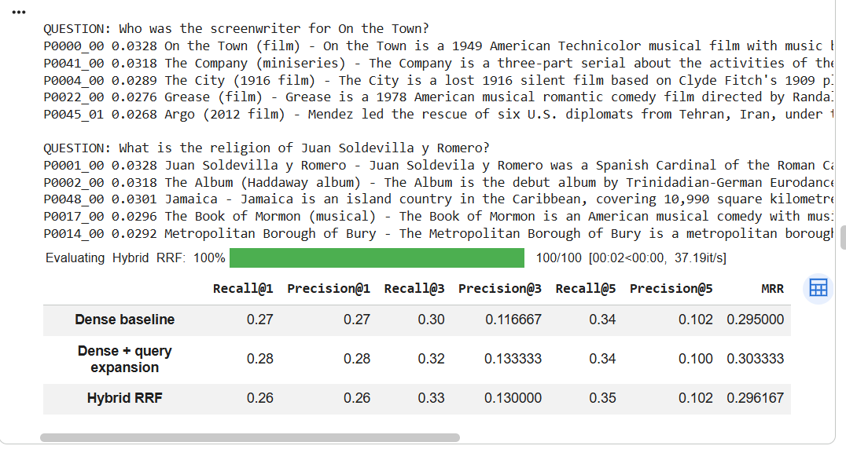
Hybrid retrieval improved Recall@3 from 0.30 in the dense baseline to 0.33, and Recall@5 from 0.34 to 0.35. This shows that combining BM25 lexical retrieval with dense semantic retrieval helped retrieve more answer-containing passages in the top results. However, Recall@1 decreased slightly to 0.26, meaning the top-ranked passage was not always the best one. This explains why a reranking step was needed.

Reranking
A cross-encoder reranker, `cross-encoder/ms-marco-MiniLM-L-6-v2`, was applied to the top hybrid candidates. Unlike dense retrieval, the cross-encoder reads the question and passage together, which can improve ranking accuracy.
Before reranking example:

Question: Who was the screenwriter for On the Town?

Before reranking, the top hybrid passages included:
1. P0000_00 — On the Town (film)
2. P0041_00 — The Company (miniseries)
3. P0004_00 — The City (1916 film)
4. P0029_00 — After Hours (film)
5. P0040_00 — Seven Songs for Malcolm X

After reranking, the top passages became:
1. P0000_00 — On the Town (film), reranker score = 6.085
2. P0036_00 — Little Children (film), reranker score = -3.398
3. P0029_00 — After Hours (film), reranker score = -3.943
4. P0041_00 — The Company (miniseries), reranker score = -4.300
5. P0022_00 — Grease (film), reranker score = -4.464
System | Recall@1 | Precision@1 | Recall@3 | Precision@3 | Recall@5 | Precision@5 | MRR
Dense baseline | 0.27 | 0.27 | 0.30 | 0.116667 | 0.34 | 0.102 | 0.295000
Dense + query expansion | 0.28 | 0.28 | 0.32 | 0.133333 | 0.34 | 0.100 | 0.303333
Hybrid RRF | 0.26 | 0.26 | 0.33 | 0.130000 | 0.35 | 0.102 | 0.296167
Hybrid + reranker | 0.32 | 0.32 | 0.35 | 0.146667 | 0.36 | 0.112 | 0.334167

Reranking produced the best retrieval results. Recall@1 increased to 0.32, Recall@5 increased to 0.36, and MRR increased to 0.334167. This shows that the cross-encoder reranker improved the ordering of retrieved passages by reading the question and passage together.
Citation-Grounded Answer Generation
The best retrieval pipeline was connected to an LLM. The prompt instructed the model to answer only using retrieved passages and cite evidence using `[P1]`, `[P2]`, etc.

Final prompt:
```text
You are a factual question answering assistant.
Answer the question using ONLY the provided passages.
Every factual claim must be supported by citations such as [P1] or [P2].
If the passages do not provide enough evidence, answer: "Insufficient evidence in the retrieved passages."
Keep the answer concise.
...
```

This prompt reduces unsupported answers by explicitly limiting the evidence source, requiring citations, and allowing abstention.

Ten Grounded QA Examples
The following 10 examples were generated using the best retrieval pipeline and citation-grounded answer generation.

Example 1
Question: Who was the screenwriter for On the Town?
Gold answers: Betty Comden, Basya Cohen, Adolph Green
Retrieved passages: P0000_00, P0036_00, P0029_00, P0041_00, P0022_00
Final answer: The answer is Betty Comden [P1].

Example 2
Question: What is the religion of Juan Soldevilla y Romero?
Gold answers: Catholic Church, Roman Catholic Church, Church of Rome
Retrieved passages: P0001_00, P0034_00, P0017_00, P0030_00, P0048_00
Final answer: The answer is Catholic Church [P1] [P3].

Example 3
Question: What genre is Haddaway?
Gold answers: Eurodance, Euro-dance, Euro dance
Retrieved passages: P0002_00, P0016_00, P0010_00, P0035_00, P0043_00
Final answer: The answer is Eurodance [P1].

Example 4
Question: Who was the composer of Chances Are?
Gold answers: Maurice Jarre, Maurice-Alexis Jarre
Retrieved passages: P0003_00, P0000_00, P0047_00, P0017_00, P0040_00
Final answer: The answer is Maurice Jarre [P1].

Example 5
Question: Who was the producer of The Pioneers?
Gold answers: Franklyn Barrett, Walter Franklyn Barrett
Retrieved passages: P0040_00, P0022_00, P0027_00, P0000_00, P0045_00
Final answer: Insufficient evidence in the retrieved passages.

Example 6
Question: Who was the screenwriter for The City?
Gold answers: Clyde Fitch, William Clyde Fitch
Retrieved passages: P0004_00, P0041_00, P0029_00, P0036_00, P0000_00
Final answer: The answer is Clyde Fitch [P1].

Example 7
Question: In what city was Jerrold Katz born?
Gold answers: Washington, D.C.; Washington; Washington DC
Retrieved passages: P0004_00, P0024_00, P0048_00, P0040_01, P0000_00
Final answer: The answer is Washington, D.C. [P3].

Example 8
Question: Who was the screenwriter for Sixteen Candles?
Gold answers: John Hughes, John Hughes Jr.
Retrieved passages: P0005_00, P0041_00, P0036_00, P0029_00, P0022_00
Final answer: The answer is John Hughes [P1].

Example 9
Question: Who is the author of Revolution?
Gold answers: Russell Brand, Russell Edward Brand
Retrieved passages: P0016_00, P0009_00, P0041_00, P0020_00, P0017_00
Final answer: Insufficient evidence in the retrieved passages.

Example 10
Question: Who was the screenwriter for The Great Fire?
Gold answers: Tom Bradby, Thomas Matthew Bradby
Retrieved passages: P0006_00, P0045_00, P0041_00, P0029_00, P0027_00
Final answer: The answer is Tom Bradby [P1].
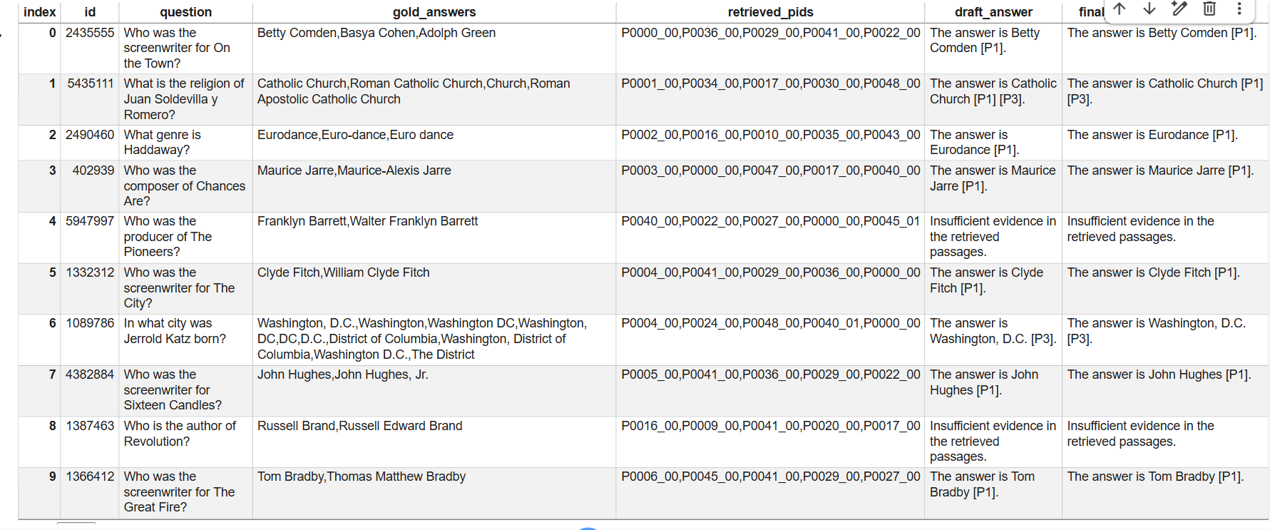
The examples show that the model usually answered correctly when the retrieved evidence contained the gold answer in the top passages. When the evidence was missing or weak, the system returned “Insufficient evidence in the retrieved passages,” which reduced unsupported hallucinated answers.

Error Analysis
Five failure cases were analysed. For each case, the failure was classified as retrieval, ranking, prompting, or generation.

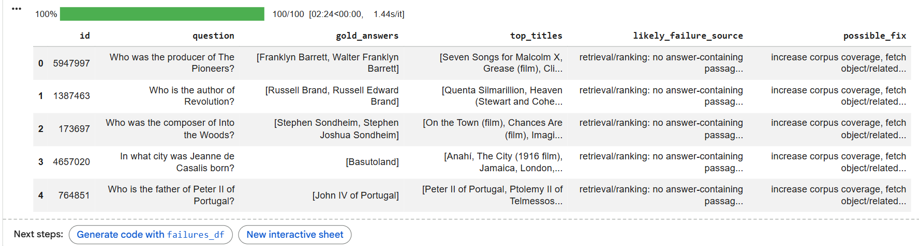
The main recurring failure was missing or incomplete evidence in the retrieval corpus. Some questions retrieved related pages but not the exact answer-containing passage. This shows that the retrieval corpus was the biggest limitation. Another failure mode was entity ambiguity, where the retriever selected pages with similar wording but not the correct subject. Query expansion sometimes helped, but it could also add noise when aliases or relationship terms were too broad.

Recurring failure modes:
1. Missing or incomplete corpus passages.
2. Ambiguous entity names.
3. Query expansion noise.
4. Reranker prioritizing related but answerless passages.

Self-Reflective RAG
The self-reflective stage checked whether the draft answer was grounded in the retrieved passages, whether the citations supported the answer, and whether the answer was complete. If the evidence was not enough, the reflection step returned “Insufficient evidence in the retrieved passages.” If the draft answer was already supported, it kept the answer unchanged.
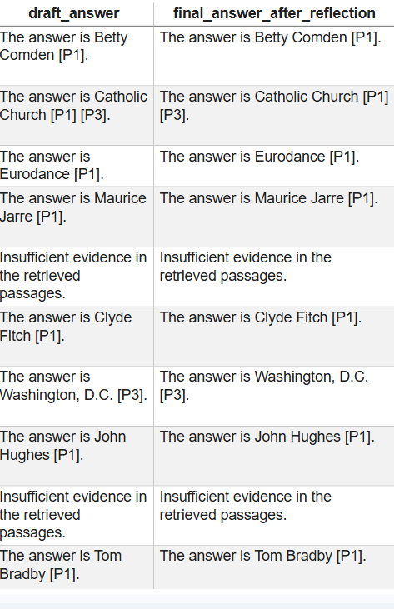

Final Comparative Evaluation
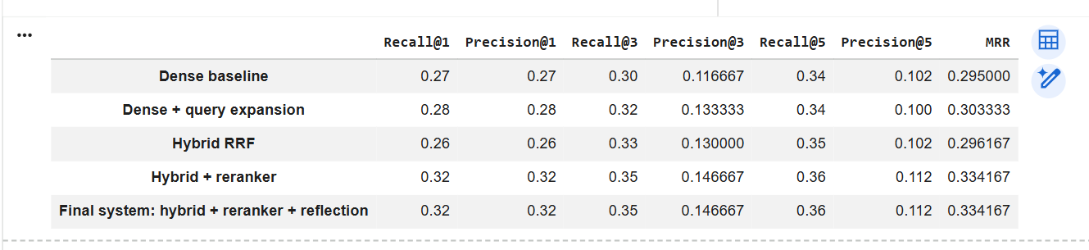

Trade-offs
Dense retrieval is fastest and simplest but may miss exact answer passages. Query expansion improves recall in some cases but can introduce noise. Hybrid retrieval is more robust because it combines lexical and semantic signals. Reranking improves final passage order but adds latency. Self-reflection improves answer reliability, citation quality, and abstention behavior, but requires an additional generation step and increases cost.

Final Discussion
Based on the results, the best retrieval setup was Hybrid + Reranked. It achieved Recall@1 = 0.32, Recall@5 = 0.36, and MRR = 0.334167, outperforming the dense baseline. The final self-reflective RAG system did not change retrieval scores, but it improved answer safety by keeping supported answers and refusing to answer when evidence was insufficient.
Limitations include the small evaluation subset, the simplified Wikipedia-summary corpus, and the automatic relevance metric based on answer string matching. This metric may miss semantically correct passages that use paraphrases.
A future improvement would be to build a larger Wikipedia corpus using full pages rather than summaries and add a stronger entity-aware query expansion method.

